Publix Transportation Business Plan
Briana Richardson
Writing Partner: Kerri Burden
Brandman University
MGTU 410

Executive Summary
Publix is an already operational grocery supermarket operating in many different cities within the U.S. Despite the stiff market competition, the company has registered good performance offering a wide range of products. Currently, the organization has initiated an aggressive plan to improve their quality service provision by introducing transportation services to its business units. The aim of the transportation service as an addition to their business venture to cater to the elderly and the disabled in Jacksonville, Florida. This is a unique market approach that seeks to serve the vulnerable in the community. For this initiative, the management of Publix expects to gain a competitive edge over its competitors considering that Jacksonville has a high population of elderly and disabled. Putting into consideration the effects of the COVID-19 pandemic, transport services to elderly and disabled will help to keep them safe from the pandemic. The company expects to get sufficient labor force needed, considering that many of the population lost their employment opportunities due to this pandemic. A comprehensive financial analysis and projection of this venture indicates that the company will be in a good possible to earn more returns on the market. Perhaps, a detailed analysis of the market environment has offered compelling insights to show that the transport service venture is uniquely positioned on the market. As the company looks forward towards a prosperous future, it is the expectation that the projected analysis would reflect the reality of the market.

Table of Contents
1. Company Overview & Product Analysis 5
1.1 Company Description 5
1.2 Product/ Innovation Description 6
1.3 Mission and Vision Statement 8
1.3.1 Mission 8
1.3.2 Vision 8
2. Industry Analysis & Trends 10
2.1 History of Publix 10
2.2 Management Structure & Key Personnel 11
2.3 Competitive Advantage 12
2.4 Service Description 14
2.5 Environmental Analysis & Scanning 16
2.3.1 PESTEL Analysis 16
2.3.2 SWOT Analysis 19
3 Marketing plan 22
3.1 Market Research & Competitors 22
3.2 Publix’s Marketing Mix 23
3.3 Customer Service 25
4 The Operations Plan 26
4.1 Process Automation 26
4.2 Driver-related operations 27
4.3 Operational Roles of the Transport Manager 28
4.4 The Operations Flow Chart 30
5. The Financial plan 32
5.3 Funds required and their sources 32
5.4 Current funding requirements 33
5.3. Funding requirements (Next 3 Years) 33
5.5 Use of funds 34
5.6 Loss Control 34
5.5 Financial Statements for Publix Company Ltd 35
5.5.1 Income statements 35
5.5.2 Balance sheets 38
5.5.4 Key Financial Ratios 44
6. The Action plan 46
7. Conclusion 50
8. Recommendations 51
9. References 52
10. Appendices 57
10.1 Appendix 1: Publix’s Corporate Structure 57
10.2 Appendix 2: SWOT analysis summary 58
10.3 Appendix 3: Social Media Competition 59
10.4 Appendix 4: The 4 Ps of the Marketing Mix 60

- Company Overview & Product Analysis
  - Company Description
Publix supermarket is commonly known as Publix. It is an employee-owned supermarket which is a private company that is solely owned by present and past employees and members of the Jenkins Family (Publix, 2020). Its ownership structure is unique and ideal in a sense that the stakeholders closely supports and follows the performance. The management is sound and fully committed to profitability, year after another. Important to emphasize, Publix operates in a retail industry in that it sells consumer goods and services to customers through multiple channels of distributions. The successful nature of Publix can be attributed to it being employee owned, where it has turned servicemen such as cashiers, baggers and bankers into its largest shareholders (Publix Grocery Store, 2017).
Additionally, the core competences for this company are their abilities to develop new products and services which are consumer friendly thus providing a wide variety of markets. Offering quality products and services that meets customers’ preferences is one of Publix’s core competency. They develop new products and services as per their customers need and they emphasize more on quality of their goods and services. For this reason, the products have received a good market reception which explains its fast growth in the recent years. That aside, exemplary customer service is another core competency. For this transport service venture, specifically, it is evident that the company will reach thousands of clients who have not been able to access such products and services.

Further on, reasonable pricing is another area of concern where the company has scored very high. Previous surveys have revealed that Publix is widely praised for offering high quality goods and services at low costs. By being consumer sensitive and doing sufficient consumer research, the company gain competitive edge in the market. Today, the company is the pacesetter with a considerable market share and notable advantage over most of the rivals in the fast moving and consumer goods.
Regarding the location of operation, Publix operates throughout the southeastern regions of the United States. It has stores in the following states; Florida, Georgia, South Carolina, Tennessee, North Carolina and Virginia (Publix; facts & figures 2018). Publix has its headquarters located at Lakeland, Florida. It has a large workforce and by 2019, the company had employed a total of 193,000 people as its employee base. These people are employed in its retails, cooking schools, corporate Offices, distribution centers and manufacturing facilities are targeted towards a sole goal of meeting customers’ satisfaction. Importantly, they all conform to and support the Publix culture of quality, and superior customer service.
  - Product/ Innovation Description
First, it is vital to review data on the provision of service to the elderly and vulnerable. In essence, a recent research survey by the National Aging and Disability Transport Centre indicates that transportation of both elderly and disabled has been a significant challenge in US. The study revealed that that eighty percent disabled and forty percent elderly do not drive thus becomes difficult to engage in short journeys and activities since they don’t acquire transport services in their areas of interest (Shaver, 2018). Given that the reduced mobility to this category, there is a significant challenge on how they go about their day, including how they purchase products and services. In addition to that, the 2012 U.S. census reported that nearly forty percent of the elderly above 65 have at least one disability and two-thirds of this population has walking or climbing challenges (U.S census, 2012).
Having realized these challenges due to impairments, Publix has swung in action to respond to the needs of the elderly, the physically disabled and the vulnerable. It is about meeting the need on the market. Publix innovation idea bases on accessibility by offering transport services to this category of clients. In turn, this promotes a symbiotic relationship within the community since they can now live and access services independently. This idea solves this problem since the company mission ensures accessibility and quality services are addressed to all the customers.
Moving on, Publix has been healthy and financially stable company due to adequate financial planning that is undertaken. This planning is undertaken in line with the company’s vision and mission operations. This includes the all the financial flow and allocations that the company handles to ensure efficiency in the use of its resources. Previous feasibility studies on the financial records have affirmed that that the company profitability has been stable over a period of time. The stability and the healthiness of the company has been achieved as result of full support of the innovation venture by the revenue and profit accrued. The company saw its revenue sales rise from $36 billion in 2018 to $38 billion in 2019. The company made a profit of $3 billion in 2019, which is a 26% increase in profit from the $2.4 billion profit they made in 2018 (Bouffard, 2020). These point to a well performing entity that is committed to achieving its goals.

  - Mission and Vision Statement
    - Mission
The mission of the Publix Company is “to be the premier quality food retailer in the world." This captures its overall intent to be the best in providing high quality foods and it engraves the DNA of its purpose on the market. The values that help the company live its mission include;
- A passionate focus on developing value to the customers.
- Have a zero tolerance policy towards wastefulness
- Upholding of dignity to all persons all the time
- Adhering to highest standards of stewardship and
- Act as responsible citizens of the community/

    - Vision
At Publix, the vision statement reads; “Dedicated to customer service and community involvement and being a great place to work and shop.”
In accordance to the mission statement to be a premier quality food retailer in the world they are dedicated in ensuring customer services and community integration and involvement and being a great place to work and shop. The company having a unique philosophy of giving best quality service and treatment has made it to be ranked as at first position in terms of customer service. Their vision too, is clearly defined to promote not just the engagement with the customers but make it a good place to working.
As a link to the mission and vision, the new transport service would help support Publix’s growth and market performance. Availability of demand of the services by the elderly and aged despite that the research indicates that it’s difficult to find (Gleckman, 2019). This is shown by less information available on the service providers and lack of independent sources to provide this services. With their customized local information Publix is in a position to give a solution to the problem hence the company should take advantage of the available opportunity to innovate and invest.

Industry Analysis & Trends
  - History of Publix
The history of Publix supermarkets incorporated dates back to 1930 when George W Jenkins founded it. Publix is a private corporation owned by the Jenkins family and its employees (Publix; facts & figures Publix supermarket, 2018). Its headquarters are situated at Lake Land, Florida. In its first year of operation, the store earned $500 during the Great Depression. By 1935, Jenkins owned five stores. By 1940 there were a total of 18 Publix operating stores. In 1950 there was a chain sale of $12.1 million from the 22 Publix supermarkets. The state of Florida contributed greatly to the growth of Publix as it became the fastest-growing state in the country. In 1965 Publix had 114 stores, and by 1970 it had 157 stores. The company reached $ 2 billion in sales, and it had 234 stores and 26,000 employees by 1979.
Additionally, Publix’s investments in technology and advertisement contributed highly to its expansion. In 1995 even after many legal woes in the previous years, Publix made it into the fortune 500 list (back in time: Publix in the 90s, the Publix checkout 2019). Today Publix has 1252 locations with 197000 employees (Publix; facts & figures: Publix supermarket 2018). Publix is said to operate throughout South Eastern United States with locations with 813 locations in Florida, 189 in Georgia, 78 in Alabama, 64 in South Carolina, 46 in Tennessee, 46 in North Carolina, and 16 in Virginia (Publix; facts &figure: Publix supermarket 2018). Publix is one of the largest United States Grocery chain stores and also the largest employee-owned company in the U.S.

  - Management Structure & Key Personnel
The Company is headed by the Chief Executive Officer who supervise the running of the company on behave of the Chairman and Vice chair of the Board. Under the CEO, there is the company president, the Chief Financial Officer and Treasurer, Senior VP and Chief Information officer as well as the Senior VP and General Counsel. Under the Chief Financial Officer and Treasurer, there are three VPs; Controller, Real Estate and Risk Management. A simplified presentation of the corporate structure is outlined in Appendix 1.

The Key managers in Publix Company are:
- Chairman- William E Crenshar, he is the grandson to George Jenkins. He has worker for Publix for 42 years, and served as CEO from 2008 to 2016 (Valverde M, 2016). He began his career as a clerk in the company.
- Chief executive Officer- Randall Todd Jones, he has worked for Publix for 36 years and started his career as a clerk. He served as the president of Publix since 2008 (Arnold K, 2016). He is the first non-family member to lead Publix.
- Senior vice president- Allison M Smith, she joined Publix in 1995 in a part time role. She has a PHD in industrial/organizational psychology, and she was promoted to give strategic oversight of customer care and social media, media and community relations and Human resource (Publix supermarket 2017).
- Executive Vice President- David R Phillips, started his career as an internal auditor in 1984. He is also the chief financial manager since 1999.
- Vice president (real estate assets) - William Raybern, started working with Publix in 1993 as a business analyst. In 2017 he was promoted to the Vice president position (Publix supermarket 2017).
Under plans to attract, develop and maintain Publix focuses on employees and invests in them for quality productivity and organization economic gain. Importantly, the key players in the Publix industry are their employees who are also their main stakeholders. They have an exclusive option to invest in the company. Company store is available only to current employees on board of directors. The employee stock ownership plan (ESOP) prohibits any transfer of value before the stakeholder fast offers the common stock to the company.
In addition, the employees are surveyed each year for feedback in compensation packages reward, policies and leadership (Publix super market 2017). Employees also take educational programs to help enhance their skills and knowledge and achieve the business objectives of Publix. Employees receive an 8.5% bonus in terms of Publix stock for 1000 work hours done per year. Also each associate has a chance to become a manager (Solomon, 2013). Retirement and financial benefits in Publix include; profit sharing, 401(k) plan, defined contribution plan and Health and insurance benefits.
  - Competitive Advantage
To focus on competitive advantage analysis Publix Company has a competitive advantage over its competitors by a focus on customers’ research to understand the trends in the market. To start with the quality of service, Publix Company having positioned as top quality service providers that have gained trust in quality provision. This makes them the best option for the preferred customers looking for a place to shop with family members. International rating of quality service provision increases demand of products and services from a particular company. By introduction of transport services in Florida for Publix company this makes the organization more accessible more than any other competitor. Accessibility of a service is a determining factor on selection of purchase as customers wish to get the best service at the preferred time with a strain in search of the service.
Worth stressing, the transport service to the elderly and the disabled will make more people have the willingness to shop from the super market as well as create awareness to their friends about the quality services and accessibility of services in the supermarket and food retail. Family members would like to shop from the places that are accommodative to their disabled and elderly family members’ thus increasing demand in the organization. Through proper customer research, the interactions between the customers and employees are nice and welcoming enough to persuade a purchasing decision placing the company at a more competitive edge than its competitors. Publix Company has its own manufacturing plant thus reducing the purchase of goods cost thus increasing the economic gains to the company thus gaining an advantage over their competitors.
When entering into a market for a particular product or service, it is obviously expected that there are some barriers and challenges that would affect the normal operation of a certain organization. Like any other service delivery industry, Publix's management expects to tackle various challenges and obstacles by the introduction of transport services. The most commonly expected challenges include competition. There are various organizations that provide transport services in Florida, like taxis. Publix will face stiff competition from the known transport service providers. It will take time for people to understand the new service introduced by Publix Company to cater to the elderly and disabled population. Another expected challenge is marketing. Publix is globally known as a food retail supermarket, and therefore this service is a great change. The new perception will take time to normalize in people's minds since the organization is not known to provide transport services to customers. Upon the introduction of any product or service in the market place there is a need to carry out market research to understand the needs and trends in consumers' tastes. These researches are costly as they require skilled personnel's, Publix also will incur such costs so as to understand their consumers' trends.

  - Service Description
The transportation service will cater to the elderly and disabled in the society to meet their needs in the food retail. This transport service is proposed to increase demand of the company’s product as well as increase profits for the company. The following is the anticipated service life cycle that will be typical of Publix’s service delivery.

Service Life Cycle
- Exploration stage: At this stage, the business does not expect to get a large number of customers as the population will not have become aware of the added service in the company. At this stage, there is need to create more awareness to the public about the new service.

- Involvement stage: At this stage, all the departments in the organizations are required to take part in creating awareness of the new service in the company with a sole goal to increase awareness about the service and increase demand of the service.

- Development stage: At this stage, the stakeholders can be involved to take part in marketing of the service. By this stage, the company will have a good number of transportation service customers and the number will be increasing due to the marketing strategies already laid.

- Consolidation stage: At this stage, the number of sales will be enough to meet the cost incurred by the service and the company will be making profit. Strategies to increase and maintain the number of customers would also be discussed to meet customers’ satisfaction.

- Stagnation stage: At this stage, the number of demands for customers will not be increasing nor decreasing. The public will already be aware of the new service. Publix will need to analyze strategies to increase demand as well as promotion of return visits for purchase.

- Decline or rejuvenation stage: At this stage, the demand for transport service in the company would increase when rebranding of the service are done or decline if no strategies are put into practice to increase the purchase of the service.

  - Environmental Analysis & Scanning
Business environment is categorized into micro and macro environments where macro environment mostly focuses on the external forces affecting the business. By use of SWOT analysis Strengths and Weaknesses are internal factors that affects the normal functioning of a business, on the other case Opportunities and Threats tend to be the external forces affecting the normal operations of a business. Then, focusing on the external factors it is important to use PESTEL as a tool to analyze the external forces. The following is the PESTEL Analysis that would followed by a SWOT analysis as it relates to operations by Publix.

    - PESTEL Analysis
  - Political factors
Publix company in introducing of transport services to their industry also expects to come along these forces they include taxation by the country, trade agreements that a particular company is required to adhere to, there are also labor regulation directing on how the organization should treat its employees. It also include environmental regulations set by the primary government giving guidelines on the environmental conservation actions that each operating business should observe.

  - Economic factors
These are very important external forces that an operating environment should take into consideration as they have effect of the economic gains of the business. They include interest rates for the loan acquisition from banks, hiring of employees, and cost of capital in acquisition of assets for start of the transport services in the organization.
  - Social cultural factors
These are factors relating to the stake holders of a particular venture. Publix Company should consider these factors at depths for better consumer understanding. They includes education level of the targeted population to understand more on this, the education level of the target customers define their purchasing decisions. Age groups and ethnic groups are other social cultural factor the Publix Company should focus on.
  - Technological factors
This is a very important factor Publix company should focus as many aspects in lives are technologically driven. Changes in technological advancement has posed negative and positive impacts to operations of businesses. In introduction of transport service in the business it is important to introduce consumer friendly technologies for ease of accessibility to the organization through mobile phones and many other gadgets.

  - Environmental factors
These factors mainly focuses on the business operating physical environment. They include the availability and usage of natural resources. Business are advised in sustainable usage of natural usage. Pollution is also a major environmental factor, companies are advised in proper disposal of waste and usage of renewable resource to enhance environmental sustainability at large. Publix is expected to adhere to the strategies laid in environmental regulations.
  - Legal factors
These relates with the political factors but their uniqueness are set on the regulations laid by the government. They include licenses fee, online policy that limits online adverts and leakage of information from a certain organization. It also focuses on property rights that an operating business should observe in its operation. Publix needs to observe the transport regulations set in U.S for ease in carrying out service provision to the customers.

Summary of PESTEL Analysis
P –Political | Taxation, labor labors & environmental regulation etc.
E- Economic | Interest rates on loans, wage rates, & cost of capital etc.
S- Sociocultural | Customer demographics; education levels, age and ethnicity etc.
T-Technological | Technological advancements e.g. apps, websites, social media
E-Environmental | Pollution control & environmental sustainability
L -Legal | Licenses fees, advertising regulations & transport regulations.

2.3.2 SWOT Analysis
- Strengths
Publix company strengths are based on the high demand driven by the high population of the baby boomers as well as the disabled in the city. Publix stands as one of the largest US regional grocery chains. Publix is among the top of the line when it comes to the grocery chain. They could use that to their advantage when implementing this innovation. Publix already provides special order service to their customers, so customers wouldn’t be surprised that they are offering transportation for their customers to shop with them. Publix is successful with coming out with new ideas and products so offering transportation shouldn’t be any different.

- Weakness
Publix has limited partnerships and that could hinder them when trying to produce this innovation. Publix doesn’t have any partnerships with other companies, and this could be a weakness for them. Creating partnerships with other companies can push them ahead and create connections into other avenues. Their organization structure is only compatible with the present business model thus limiting expansion in adjacent product segments. With a limiting business model, it would be hard to expand into anything different.
- Opportunities
Publix would be the first grocery store to offer exclusive transportation. There are no current grocery stores that offer an exclusive transportation service for the elderly and disabled people who can’t drive around themselves. Because Publix would be the first ones, there would be no competition from any other grocery stores. With creating a transportation innovation, Publix can focus on digital marketing to get the word out that they are offering this new service. Social media is a new way to reach millions of people in short amount of time, so using social media would be ideal as well. Providing transportation and offering subscriptions would provide a new stream of revenue for Publix.
- Threats
The Company’s threats are the competitors and for this reason there is need to improve the quality of service to meet customers’ satisfaction. Once Publix announces this innovation, there will be competitors trying to mimic and recreate their idea. Another threat is that Publix will have to hire drivers and pay for costs related to vehicle inventory, which will increase their labor and inventory cost.
The Summary of the SWOT analysis is presented in the table below and its graphical figure is outlined in Appendix 2.

Strengths  - High demand for products & services among baby boomers. | Weaknesses  - Limited partnerships that hinder expansion.
Opportunities  - No grocery stores offer an exclusive transportation service. | Threats  - Competition is quite tough in this sector.

- Marketing plan
  - Market Research & Competitors
Publix will use its competent marketing as well as sales team to market its new service. The marketing team will conduct a primary as well as a secondary research in order to determine the tastes as well as the preferences of its customers in order to advice the responsible transport department. The primary research will entail collecting appropriate data from its customers through interviews and online questionnaires. On the other hand, the secondary research will entail the marketing team conducting a review of available literature on marketing.
Publix Company faces stiff competition from handful of organization. For instance, there is Albertson Company which was founded some years later after Publix. It offers the same products as Publix. There are others such as Kroger, Sprout Farmers and many others. The graph below shows the comparison of net incomes of the Publix company competitors.
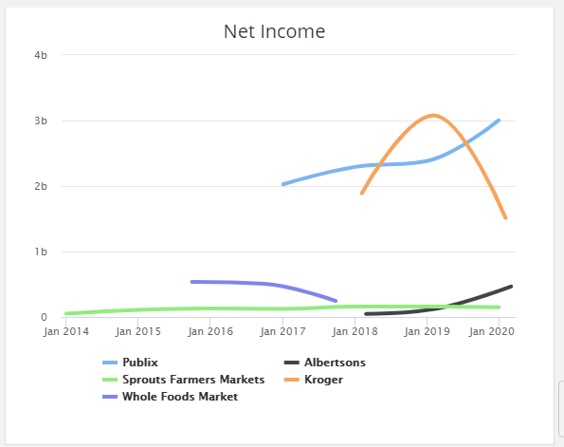

In addition, a review of social media reveals that Publix is a well performing entity with a visible social media brands that is well maintained to boost its profile. On the social media, however, social media still and much is needed to keep the brand visible and keep customers engaged. Appendix 3 gives a summary of social media analysis of Publix competitors.

  - Publix’s Marketing Mix
The marketing mix outline the key strategy that the company uses to deliver value on the market. A structural representation of the marketing mix as outlined by McAcrthy (2016) is given in Appendix 4.
- Product
Publix is offering retain and plans are underway for transport service provision. Product or service uniqueness persuades customers’ decision to purchase a certain product or a service. Publix preferred transport service is unique in that there has not been any other retail supermarket offering transport services to elderly and disabled in the society.
- Price
Price is the amount changed for the provision of service or purchase of a product. The best price selection should be one that is considerate to customers and at the same time one which maintains economic sustainability of the business. The subscription will be $29.95 monthly with a two time per week limit for roundtrip rides. There will also be a day pass option for one ride only that will cost $15 for a roundtrip. That will be available for customers who don’t want to pay a subscription or don’t frequent the grocery store that often.
- Promotion
These are the marketing strategies used by the organization and how effective the marketing strategies are in increasing demand for products and services. Publix Company has a good package that is consumer friendly as they have an added advantage of transport services to the elderly and disabled in the society.
- Place
Location of a business is a major factor that should be considered as it has impact on purchase decision. A good location should be one that is easily accessible by local means of transport. Jacksonville being a densely populated areas Publix company is assured of continuous inflow of sales and demand of the transport services due to the high number the elderly and disabled.
By extension it is vital to briefly explore the available distribution channels. Publix Company uses 4 types of distribution channels of its products and services to customers. One of them is direct channel which is the purchase of the products direct from the producer to the consumer. The 2nd one is retail channel where customers purchase their preferred goods and services from retails. The 3rd channel of distribution is wholesale channel where retailers source purchase their products from Publix to sell to customers. The last one is Agent channel when there are agents or brokers who purchase the goods and in place of the final consumer.

  - Customer Service
Publix like any other operating business has various strengths and weaknesses that have impact on the customers’ satisfaction of their needs. To focus on strengths the employees consideration and priorities given to them motivates them to deliver quality service to the customers. This make the company to be the top ranked in terms of quality service provision. Many customers are very sensitive in terms of quality service provision as they are aware of what they need from a particular organization. In terms of weaknesses, one of the main weaknesses in the Publix Company is that they spend a lot in attrition of workforce for better service delivery. Publix takes initiatives to educating of its employees and also profit sharing strategies which are only unique to this organization as their competitors doesn’t have such strategies. The company structure makes it complicated to handle a small issue on the ground as each person is answerable to a higher personnel in the organization structure. To handle a small issue on ground it spends a lot of time as the recommendation has to come from CEO down to the clerk.

- The Operations Plan
This section outlines how actual plans would run in the organization to ensure that all the elements are functioning seamlessly without interruption. It also details the role of the operations manager, and the expected flow chart showing the operations.
  - Process Automation
First, being a transportation service, the operations will solely be handled by the Transport service department. The department will oversee logistical plans as they relate to the transportation, drivers and other diverse issues. It is essential to function that the department will roll out an information system to ensure that most of the processes are automated. Research has indicated that automation is crucial to ensure better service efficiency, reduction of errors and swift correction of delays/inefficiencies (Chaudhari, 2020). For Publix, having an integrated information system would be suitable to ensure that the operations are well coordinated and they flow seamlessly. This in turn will result in more productivity in the transportation service department.

By extension, the department will develop a website for online booking of the transport service for the elderly and disabled. The preferred customer will be required to do online booking for the service at least 45 minutes prior to the delivery. There will be service associates who will help the customer with purchase of goods in the business upon arrival. The online booking systems will be managed by an information systems manager who will ensure everything runs well.

4.2 Driver-related operations
There would be specific operations are concerns to the drivers who are crucial pillars in success of the transportation system. The information system will have a driver’s portal where they will be required to clock in and go “active” so management can identify how many vehicles are available at any given time. The management, through the transport manager, would then be required to assign the customers to the drivers who are currently active.

The information systems will offer real time information on the status of the drivers, including tracking the orders. If the order is enroute to the client, the system will notify the clients that the order is ready and will approximate the delivery time. For instance, swift deliveries will take between 15minutes to half an hour depending on the proximity and traffic conditions.

Additionally, the ability to gather real data will also inform the drivers on the safest and shortest routes to use in their deliveries. For example, if there has been an accident or incident on the road, the drivers will get real-time navigation alerts to use alternative routes. This will ensure that digitization supports effective delivery of service and also ease the pain and discomforts for the drivers. By extension, the website will have a feedback option. It will provide a platform for customers to port their after-service comments for quality service provision as well as meeting the customers’ preferences.

  - Operational Roles of the Transport Manager
It has already been identified that the transport manager will be the key operational personnel for the transportation service. He will heavily rely on the information system to allocate the delivery duties as the firm receives requests. He will also identify which drivers and vehicles are available and ready to handle the deliveries. In essence, the manager will oversee all logistical plans to ensure every runs smoothly. At later stages, the company will employ more employees to cater to the increasing number of customers if need arises.

Role of Automation in the Operations of Publix’s Transportation Service
Areas of Focus | Personnel Involved | Functions | Objectives
Booking | Customers | - The website will allow customers to place their orders in readiness for delivery.  - The system will provide real time tracking data so that the customer know the progress of order processing, delivery and expected arrival time. | To make ordering easy and convenient as possible.  To streamline order processing without delays, and confusion.
Feedback management | Customers | The website will offer a platform to record the customers’ feedback, not just on the rating of drivers but overall experience of the service. | To use the customer feedback to improve operations.
Service Delivery | Drivers | - Clocking in & out/  - Automated allocation of delivery tasks.  - Offering real time data on routes. | To streamline service delivery and offer real time data to ensure swift and effective delivery of goods to customers.
Managing Deliveries | Transport (Operations) Manager | - Drivers allocated tasks.  - Knowing status of drivers and vehicles.  - Fire and hire.  - Swift communication with drivers | To suitably manage the drivers and support effective service delivery.

  - The Operations Flow Chart
The following is a flow chart that generally depicts the operations in the organization from the time the customer places an order to when the order is received.
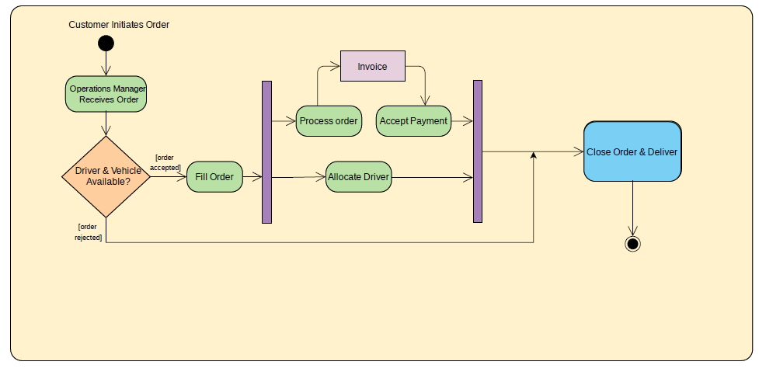

From the above illustration, the operations typically begin when a customer goes online and places an order for specific products via the website. The order initiation is picked up by the operations manager via the information system. The manager through the same system identifies if any driver are available to be assigned the delivery work. If they are available, the order is processed, otherwise it is queued pending a slot in the driver/vehicle. Oder processing entails selection of the needed products, allocating the driver and handling the payment system. When the payment is allocated, the products are packaged and put in the vehicle. The customer receives notification that the order is processed and enroute as the driver physically begins the process of order delivery.

  - Marketing & Innovation Operations
With the transportation department, there is a marketing liaison officer who is tasked with ensuring the marketing functions of the department are effective and impactful. This personnel makes regular reports on the transportation processes and recommends specific actions to boost the marketing operations. For instance, instead of using plain colored vans for delivery, the individual recommends colorful paintings to capture the interest of the customers, both current and potential clients. The communication include call numbers and social media pages which makes the van an active ad as it makes deliveries on the market.

In conjunction with the roles of marketing, this officer also liaises with other departments of the organization to boost innovation and creativity. The creative message described above is one way to excite the audiences and boost awareness of what the company does. This kind of branding is suitably made visible and attractive to audience such as senior citizens who have visual impairments. Other innovative schemes could be recruitment of a fairly older adult as a driver to appeal to the specific segment on the market.

- The Financial plan
Publix Company will need a total of approximately $150,000 to start its transport service operation. That will cover the startup materials, the hiring process, and marketing. $100,000 will be sourced from their account while the rest $50,000 will be acquired as a loan from a local bank. The company will purchase two vehicles at the first stage and another two after a period of about 4 months checking the progress. The cost of a wheelchair accessible van is about $40,000. So, it will cost $80,000 for the first two vehicles. Some drivers will also utilize their own vehicles for transportation. Insurance will cost about $200-250 per vehicle. To save money, Publix can require rideshare insurance for every delivery driver that uses their own vehicle. For the hiring process, Publix can hire two full time delivery drivers to drive their accessibility vans. Every other driver can be an independent contractor, so Publix can cut costs. A vehicle will carry a minimum of 4 passengers at a go to minimize the cost as well maximizing the profit to the company.

  - Funds required and their sources
To establish and run the transport service operations, Publix Company Ltd would require an estimated $150,000. These funds will go into various functions such as the purchase of transport vans, cargo handling equipment such as forklifts, and other related material in cargo handling. For instance, two vans will be bought at a combined cost of $80,000. The cash would also be used in the hiring of employees in the transport service, and initial marketing operations to publicize this segment of the company.

Concerning the source, about 67% percent of these funds ($100,000) will be sourced from the company’s current accounts while the additional $50,000 would be financed by a commercial bank inform of a 3 year loan facility. For growth-oriented start-up, use of debt financing is effective especially when there is a projected growth and liquidity for the enterprise (Coleman et al., 2014). For the transport operations, financial projection indicate sustained growth and hence, a well informed choice to pursue the debt financing.

  - Current funding requirements
Currently, the company is financed largely by its profits and the equity base. Today, the debt financing is only about 35 percent which is a good indication of growth since more reliance on debt signals financial distress. There is however need to further reduce debt financing to up to 25 percent while maintaining a growth of its revenue streams.

5.3. Funding requirements (Next 3 Years)
Over the next three years, there will be notable increase in the debt financing since the launch of the transport operations would require loan funding. From the projects, the key ratio such as debt to equity financing would increase up to 0.55 by the third year pointing to debt financing. Nonetheless, both the current ratio and working capital ratio would improve affirming the efficacy use of assets to generate more revenue for growth. A detailed presentation of the ratio analysis is shown in the following section.

  - Use of funds
In the three years of trading and financial projections, the funds available would be used to increase the asset base and therefore, have a positive impact on growth of the enterprise. For instance, one more delivery van would be purchased in the second year and two more in the third year. It is projected that as more growth would be realized, the assets would be expanded to increase capacity to serve more clients over time.

  - Loss Control
The management will undertake periodic audits and risk management to control loss and risk arising from the transport operations. For instance, transport scheduling will be improved to ensure maximum operations with minimal loss. In addition, nee measures such as design of a transport software will ensure more optimal and cost saving operations. For instance, this GPS-fitted software would guide drivers on shortest routes to ensure saving both time and fuel costs.

5.5 Financial Statements for Publix Company Ltd

5.5.1 Income statements

 |  |  | Publix Company Ltd
 |  |  | Income Statement
 |  |  | For the year ending Dec 31 2021, Dec 31 2022 & Dec 31 2023
 | Revenue |  | 2021 | 2022 | 2023
 |  | Sales revenue | 97,200 | 120,650 | 139,250
 |  | (Less sales returns and allowances) | (310) | (450) | (710)
 |  | Service revenue | 11,650 | 12,400 | 13,310
 |  | Interest revenue | - | - | -
 |  | Other revenue | - | - | -
 | Total Revenues |  | 108,540 | 132,600 | 151,850
 |  |  |  | [42]
[42] | Expenses
 |  | Advertising | 1,300 | 1,450 | 1,950
 |  | Bad debt | - | 200 | 550
 |  | Commissions | 355 | 500 | 765
 |  | Cost of goods sold | 24,000 | 32,100 | 37,250
 |  | Depreciation | 120 | 120 | 120
 |  | Employee benefits | - | 150 | 400
 |  | Furniture and equipment | 420 | 500 | 640
 |  | Insurance | 950 | 1,100 | 2,000
 |  | Interest expense | 1,780 | 1,950 | 2,280
 |  | Maintenance and repairs | 800 | 1,150 | 1,750
 |  | Office supplies | 230 | 350 | 400
 |  | Rent | 2,050 | 2,050 | 2,050
 |  | Research and development | - | 150 | 350
 |  | Salaries and wages | 12,500 | 13,400 | 15,700
 |  | Utilities | 750 | 910 | 1,110
 |  | Other | 4,400 | 5,100 | 7,400
 | Total Expenses |  | 49,655 | 61,180 | 74,715
 |  | Net Income Before Taxes | 58,885 | 71,420 | 77,135
 |  | Income tax expense | 17,666 | 21,426 | 23,141
 | Income from Continuing Operations |  | 41,220 | 49,994 | 53,995
 |  | {42} |  | [42]
 | Below-the-Line Items
 |  | Income from discontinued operations | - | - | -
 |  | Effect of accounting changes | - | (900) | (1,500)
 |  | Extraordinary items | - | - | -
 | Net Income |  | 41,220 | 49,094 | 52,495

Brief Analysis of Income Statement:
The projected profit and loss statement paints a picture of an enterprise on stable path to growth. For the three year period, the revenues would increase consistently showing a potential to generate profits for the transportation service. It is also evident that the expenses incurred by the company would rise considerably over the same period. For instance, both the cost of goods and taxation expense offer an incremental pattern but so would be the anticipated sales revenues. Additionally, the insurance costs of the motor vehicles would rise as the transportation service expands its fleet to best service the market. An expanded fleet would also mean an increase in wages and salaries of the drivers. The utilities would also rise as the company seeks new storage facilities for the products. However, other costs will have minimal impact on overall trading such as the changes on the accounting measures. Bottom-line, the anticipated net incomes would rise for the projected three years as the company aggressively grows and expands on the market.

5.5.2 Balance sheets

 |  |  | Publix Company Ltd
 |  |  | Balance Sheet
 |  | For the year ending Dec 31 2021, Dec 31 2022 & Dec 31 2023
 | Assets |  | 2021 | 2022 | 2023
 | Current Assets
 |  | Cash | 19,800 | 26,300 | 30,030
 |  | Accounts receivable | 6,100 | 8,140 | 8,850
 |  | Inventory | 13,750 | 14,900 | 16,350
 |  | Prepaid expenses | 3,280 | 3,850 | 4,990
 |  | Short-term investments | -
 |  | Total current assets | $ 42,930 | $ 53,190 | $ 60,220
 | Fixed (Long-Term) Assets
 |  | Long-term investments | 6,100 | 7,350 | 9,250
 |  | Property, plant, and equipment | 12,050 | 14,070 | 15,770
 |  | (Less accumulated depreciation) | (2,200) | (2,200) | (2,200)
 |  | Intangible assets | 2,670 | 4,300 | 6,740
 |  | Total fixed assets | $ 18,620 | $ 23,520 | $ 29,560
 | Other Assets
 |  | Deferred income tax | 3,650 | 5,590 | 7,660
 |  | Other | 6,850 | 7,544 | 8,410
 |  | Total Other Assets | $ 10,500 | $ 13,134 | $ 16,070
 | Total Assets |  | $ 72,050 | $ 89,844 | $ 105,850
[42] | Liabilities and Owner's Equity
 | Current Liabilities
 |  | Accounts payable | 7,420 | 8,200 | 10,535
 |  | Short-term loans | 4,280 | 6,000 | 8,540
 |  | Income taxes payable | 2,950 | 3,300 | 3,700
 |  | Accrued salaries and wages | 2,100 | 3,950 | 5,400
 |  | Unearned revenue | - | - | -
 |  | Current portion of long-term debt | - | - | -
 |  | Total current liabilities | $ 16,750 | $ 21,450 | $ 28,175
 | Long-Term Liabilities
 |  | Long-term debt | 4,500 | 5,200 | 7,200
 |  | Deferred income tax | - | 1,700 | 2,330
 |  | Other | - | - | -
 |  | Total long-term liabilities | $ 4,500 | $ 6,900 | $ 9,530
 | Owner's Equity
 |  | Owner's investment | 9,580 | 12,400 | 15,650
 |  | Retained earnings | 41,220 | 49,094 | 52,495
 |  | Other
 |  | Total owner's equity | $ 50,800 | $ 61,494 | $ 68,145
 | Total Liabilities and Owner's Equity |  | $ 72,050 | $ 89,844 | $ 105,850
 |  |  |  | {42}

Brief Overview of the Balance Sheet:
The statement of financial position indicates how the assets and liabilities will be treated, n respect to income and shareholders’ wealth. While the current assets are expected to rise, the rise is not as reliable as those of the fixed assets. This points that there would be a possibility of liquidity problems. In this regard, the management will put emphasize on growing the current assets to keep the company as liquid as possible.

On the other hand, while there is an increase in long term debt liabilities, the management stresses on less reliance on debt due efficiency on operations to generate more incomes. This is a good move since sound financial performance means relying less on debt and more on the injected capital. Besides, retained earnings would be higher signifying a return of the earned incomes to grow operations. Importantly, there is an increase in the owners’ capital investment especially in the second and third years. More capital injection would boost operations and keeping the reliance of debt as low as possible
. 5.5.3 Cash flow statements

 |  |  |  | Publix Company Ltd
 |  |  |  | Cash Flow Statement
 |  |  |  | For the Year Ending Dec 31, 2021
 |  | Jan | Feb | Mar | April | May | Jun | July | Aug | Sept | Oct | Nov | Dec
 | Opening Cash Balance | 15700 | 37,700 | 69,400 | 96,700 | 111,500 | 169,100 | 222,800 | 257,100 | 292,600 | 334,200 | 330,500 | 348,500
Operations
Cash receipts from
 | Clients | 394,500 | 406,800 | 410,300 | 423,700 | 444,100 | 460,200 | 464,900 | 470,100 | 472,000 | 474,500 | 477,300 | 479,600
 | Other Operations | 0 | 0 | 0 | 0 | 0 | 0 | 0 | 0 | 0 | 0 | 0 | 0
Cash paid for
 | Inventory purchases | (129,400) | (131,900) | (132,200) | (133,200) | (134,900) | (136,800) | (138,900) | (140,700) | (149,300) | (149,900) | (150,200) | (150,900)
 | General operating and administrative expenses | (48,700) | (49,300) | (49,800) | (50,200) | (51,900) | (52,300) | (53,100) | (54,600) | (55,300) | (56,200) | (57,600) | (58,300)
 | Transport logistics & expenses | (22,600) | (24,100) | (26,100) | (27,300) | (28,200) | (28,900) | (29,300) | (31,200) | (34,600) | (36,200) | (37,100) | (38,400)
 | Wage expenses | (44,300) | (47,200) | (48,200) | (49,500) | (50,700) | (52,300) | (53,400) | (55,800) | (56,600) | (57,900) | (58,700) | (60,200)
 | Interest | (11,200) | (12,300) | (12,700) | (13,200) | (13,700) | (14,400) | (15,500) | (16,700) | (17,900) | (18,200) | (19,100) | (20,300)
 | Income taxes | (28,300) | (29,200) | (31,700) | (32,800) | (33,700) | (34,200) | (34,900) | (35,600) | (37,400) | (38,300) | (39,600) | (40,200)
Net Cash Flow from Operations |  | 110,000 | 112,800 | 109,600 | 117,500 | 131,000 | 141,300 | 139,800 | 135,500 | 120,900 | 117,800 | 115,000 | 111,300
Investing Activities

Cash receipts from
 | Sale of property and equipment | 26,400 | 29,400 | 33,600 | 33,600 | 33,600 | 33,600 | 33,600 | 33,600 | 33,600 | 33,600 | 33,600 | 33,600
 | Collection of principal on loans | 1,200 | 2,800 | 2,700 | 1,800 | 1,600 | 2,300 | 2,400 | 2,300 | 2,100 | 1,900 | 2,600 | 2,800
 | Sale of investment securities
Cash paid for
 | Purchase of property and equipment | (49,100) | (51,100) | (52,500) | (54,900) | (61,200) | (63,500) | (70,000) | (69,200) | (67,400) | (71,200) | (74,400) | (75,900)
 | Making loans to other entities | 0 | 0 | 0 | 0 | 0 | 0 | 0 | 0 | 0 | 0 | 0 | 0
 | Purchase of investment securities | (12,500) | (9,900) | (11,200) | (10,500) | (9,900) | (13,200) | (12,700) | (11,300) | (12,400) | (11,900) | (12,200) | (12,800)
Net Cash Flow from Investing Activities |  | (34,000) | (28,800) | (27,400) | (30,000) | (35,900) | (40,800) | (46,700) | (44,600) | (44,100) | (47,600) | (50,400) | (52,300)
Financing Activities

Cash receipts from
 | Issuance of stock | 12,800 | 0 | 0 | 0 | 14,300 | 0 | 0 | 0 | 15,600 | 0 | 0 | 16,300
 | Borrowing | 0 | 0 | 0 | 0 | 0 | 0 | 15,200 | 0 | 0 | 0 | 0 | 14,800
Cash paid for
 | Repurchase of stock (treasury stock) | (8,700) | (10,000) | (10,900) | (9,700) | (11,700) | (9,600) | (10,200) | (12,500) | (13,100) | (11,000) | (10,600) | (12,700)
 | Repayment of loans | (39,400) | (42,300) | (44,000) | (42,800) | (40,100) | (37,200) | (41,700) | (42,900) | (37,700) | (38,200) | (36,000) | (35,900)
 | Dividends | (18,700) | 0 | 0 | (20,200) | 0 | 0 | (22,100) | 0 | 0 | (24,700) | 0 | 0
Net Cash Flow from Financing Activities |  | (54,000) | (52,300) | (54,900) | (72,700) | (37,500) | (46,800) | (58,800) | (55,400) | (35,200) | (73,900) | (46,600) | (17,500)
Net Increase in Cash |  | 22,000 | 31,700 | 27,300 | 14,800 | 57,600 | 53,700 | 34,300 | 35,500 | 41,600 | (3,700) | 18,000 | 41,500
 | Cash at End of the month | 37,700 | 69,400 | 96,700 | 111,500 | 169,100 | 222,800 | 257,100 | 292,600 | 334,200 | 330,500 | 348,500 | 390,000

Brief Analysis of the Cash flow Statement:
The 12-Month cash flow statement reveals the money coming in and that which is paid out in the frequent operations of the company. As far as liquidity is concerned, the cash flow statement needs to look appealing and immune to shocks in the market. In reviewing the cash flow statement above, within the first three months, the liquidity is low as noted by lower amounts of net cash available for business operations. Usually, this is the expected scenario since the transportation service would be fairly new and the inflows are slow. They should however be steady as time progresses.

Nevertheless, in the following months, the increase is net cash available is projected to increase significantly as the transport services register a positive impact on the company revenue. It is expected that the inflows will be steady and much more than in the earlier months. In some months such as in October, business fluctuations would result in negative movement of net cash but the enterprise is expected to be resilient to adverse market conditions. Therefore, long term cash projections are in favor of more growth and liquidity to the company.

5.5.4 Key Financial Ratios

Common Financial Ratios | 2021 | 2022 | 2023 | Explanation
Debt Ratio  (Total Liabilities / Total Assets) | 0.29 | 0.32 | 0.36 | This ratio measures the amount of total debt to total assets. From the projected amounts, it evident that debt would make only about a third of the asset base. This signals a good path to growth of the business.
Current Ratio  (Current Assets / Current Liabilities) | 2.56 | 2.48 | 2.14 | This ratio outlines how easy the company would use its current assets to settle short term obligations. An ideal ratio is between 1.2 and 2 (Madushanka and Mathyinparasan, 2018). This ratio is above the ideal rate and shows the business will be liquid and able to meet obligations in the short run.
Working Capital  (Current Assets - Current Liabilities) | 26,180 | 31,740 | 32,045 | Just like the current ratio, this ratio shows that the company is able to meet its obligations since the different of assets to liabilities is positive.
Assets-to-Equity Ratio  (Total Assets / Owner's Equity) | 1.42 | 1.46 | 1.55 | It measures the extent to which the enterprise is funded by assets as opposed to equity/debt (Hantono, 2018). Since it is a positive ratio for Publix, it means the asset base will be solid since it holds more assets to finance its operations.
Debt-to-Equity Ratio  (Total Liabilities / Owner's Equity) | 0.42 | 0.46 | 0.55 | Just like the previous ratio, this ratio indicates that what kind of financing supports a business. Since this ratio is low (below 1), it means that less of financing bases on debt and more on equity.

5.6 Determination of Capital Requirements
For Publix, the goal is capital requirements is to maintain liquidity while relying less on debt. While at the beginning, debt financing would be effective to kick-start the operations of the transport service, the following years show less reliance on debt to finance the operations of the company. Cost control and quicker settling of debt obligation would keep the company more liquid. Additionally, more injection of equity by the investors would offer a better capital base to intensify operations without necessary seeking debt financing.

5.7 Determination of Funding Sources
Debt financing will be first sought to start the start the transport service operations with $50,000 sourced from a financial institution. The company will however provide $100,000 from its accounts to start the transport segment. It is anticipated that this segment will have a positive impact on the sales revenue as shown on the financial statements such as the projected income statement. Essentially, after the first year more investments of equity by the owners will be the most preferable funding sources to finance the transport operations. Use of retained earnings will also boost the transport operations.

- The Action plan
First to support the active running of the project, the office of the transport manager will created and specific roles outlined. The transport manager will be in charge of all administrative and logistical operations. The transport department manager will be required to forward all the activities run by the department on weekly basis. The duties will include inspections of motor vehicles and directing relevant actions for repair and maintenance. The drivers will report to the transport manager and discuss any major issues. The manager will ensure that the drivers conform to the schedules given to them. The manager will also keep updated and accurate records related to all the transport deliveries. The manager would have the final authority on general logistical operations such as dispatch, routing and tracking. They will also be the reference person in case of third parties such as handling issues with law enforcement.

Secondly, Publix will have to hire drivers. The process will begin with advertising the job positions, the requirements and qualifications. For instance, one key requirement is that the company would need to hire drivers to drive the wheel chair accessible vans. Prospective candidates will apply and a specified number of drivers reached out for interview shortlisting. In a process of transparency and fairness, qualified candidates will be hired on a full time basis. Importantly, during the hiring process, management will need to obtain a motor vehicle report, drug test, and criminal background check. Post hiring training will be provided as induction to the corporate cutlet, actual processes and expectations in doing the jobs.

Upon the end of this hiring, selection and training exercise, each driver will be allocated a vehicle for service delivery. While every other driver would utilize their own vehicle, they will have rideshare coverage along with full coverage on their vehicle. Vital to emphasize, each driver will be responsible for the vehicle but will include but not limited to sticking to the outlined routes and submitting to the garage for regular inspection. Irresponsible actions such as using the vehicles for their own personal use, deliberate time wastage or unreasonable deviation from the assigned routes will amount to disciplinary action.

Then, the company will develop a process to request transportation by phone and on their website. The drivers will use their apps where customer orders/requisitions will reflect on their apps. As earlier outlined, the transportation department will embrace automation and digitization to ensure information flow is timely and appropriate decisions are made in the best interests of the needs of the customers. By extension, there will need to be marketing and promotion activities so that customers are aware of the new service.

Moving on, the vehicles will be checked on a weekly basis to ensure that they are in good condition. The drivers and mechanics will compile comprehensive reports on the status of each vehicle. If any major issues arise, such as need for more repair, the transport manager will coordinate with funding to ensure that prompt action is taken. Failure to adhere to the inspection guidelines will attract disciplinary action and even dismissal.

In addition to that, the transport manager will keep the analysis of costs in the running of each vehicle. Monthly reports will be tabled to assess the performance of each vehicle. A cost-benefit analysis would be integral to determine the viability of each vehicle. All mileage and routing details will be crucial to such cost benefit analysis. Vehicle mileage should be recorded before and after taking any journey during the operation. Analysis on the cost incurred will be done monthly, along with the profits, to determine the impact of the transport service introduction to the business.

Finally, the transport manager would liaise with the HR department to address issues related to the drivers. For instance, they would oversee insurance claims to ensure that workers are well compensated in case of injury. These activities would be on an on-demand basis but monthly reports will keep track of such issues. Additionally, matters relating to employee training in this department will be handled by the transport manager. For instance, he will avail opportunities for drivers to take part in workshops about safe and green-conscious driving on the roads. After such training sessions, relevant reports will be prepared and filed.

The following graphical representation outlines the action plan at it regards the service delivery at Publix’s transportation service department.

The Summary of Publix’s The Action Plan
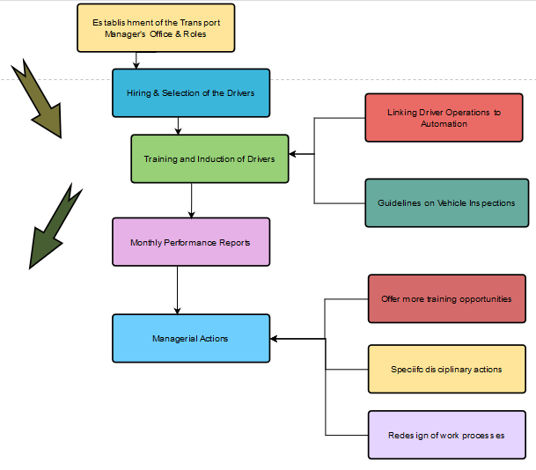

- Conclusion
Today’s service industry has seen gradual changes in that today customers are aware of what they want and they expect to get quality service from a service provider. Due to this, there is a need for the service provider to do enough market research on the customers’ changing trends in order to satisfy customer needs. For the case of Publix food retailing business, they have gained competitive edge by introducing a supportive service to cater to the elderly and disabled in the society. They are being considerate to the high population of elderly and disabled in Jacksonville and through this, will get more profits from the increased demand of their goods. They will offer transportation service which will be a new niche, one which is uncommon for the supermarket enterprises. A detailed environmental scanning has been undertaken shown the nature of the market and the positioning of the Publix’s transportation service. An analysis of the completion, the marketing actions and operations plans has been provided to gauge how the service will be implemented on the market. Finally, a detailed financial projections and analysis have been presented which alludes to the viability of this transport venture in improving the performance and growth of the company. Bottom-line, it has been identified that the transportation service would be a successful venture, targeting elderly and the vulnerable and will have appositive impact on the company in general.

- Recommendations
The following are some of the identifiable recommendation to improve the service delivery of the Publix transport service;
- Expanding the partnership base: the company needs to reach out to other partners in the transport industry as a way to expand without incurring high costs in purchase of assets. For instance, it can partner with start-ups to cover more routes and thus serve more clients in efficient ways.
- Use of independent contractors: As a forward looking company, Publix should consider hiring independent contractors to lower the hiring costs. They come on board with own vehicles, vehicle rideshare insurance, and gasoline. They however need to operate within the philosophy and culture of Publix Company.
- Proper Market Segmentation: the transportation service needs to actively serve locations with a high percentage of elderly and disabled customers in the area. Since service to the vulnerable in the company’s DNA, it is vital to aggressively seek this market segment and offer holistic service as per the needs of the clients. Partnership with nonprofit organizations and social workers can help map out these locations.

- References
. The United States Census Bureau. (2020). 65 and Older Population Grows Rapidly as Baby Boomers Age. Retrieved 6 November 2020, from https://www.census.gov/newsroom/press-releases/2020/65-older-population-grows.html.
Publix (2017). About Publix. Retrieved on 6 November from www.publix.com/aboutus.
Ameratunga, S., Spray, J., Anderson, A., Wiles, J., Witten, K., & Ofanoa, M. et al. (2019). Inclusive Streetscapes: Disabled People and Older Citizens Charting a Roadmap to Equity. Journal of Transport & Health, 14, 100729. Doi: 10.1016/j.jth.2019.100729
Arnold, K. (2016). Publix CEO brings energy to new role. Orlando sentinel. Retrieved on 6 November from https://digitaledition.orlandosentinel.com/tribune/article_popover.aspx?guid=a3095840-4e13-4f85-b068-456557735397
Bouffard, K. (2020). Publix reports more financial success. Retrieved 6 November 2020, from https://www.theledger.com/news/20200302/publix-reports-more-financial-success.
Chaudhari, N. (2020). Role of Automation in Business Development. American Journal of Theoretical and Applied Business, 2 (1), 1-17
Coleman, S., Cotei, C., & Farhat, J. (2014). The debt-equity financing decisions of U.S. startup firms. Journal of Economics and Finance, 40 (1), 105–126. Doi: 10.1007/s12197-014-92
Connolly, J. (2019). Finding Transportation Services for seniors. Agingcare.com. Retrieved 6 November 2020, from https://www.agingcare.com/articles/finding-transportation-services-for-seniors-104572.htm.
Disability & Health U.S. State Profile Data: Florida | CDC. Centers for Disease Control and Prevention. (2020). Retrieved 6 November 2020, from https://www.cdc.gov/ncbddd/disabilityandhealth/impacts/florida.html.
Disabled population U.S. by state 2018 | Statista. Statista. (2019). Retrieved 6 November 2020, from https://www.statista.com/statistics/794278/disabled-population-us-by-state/.
Facts and figures. Publix supermarket retrieved March 7, 2018.
Gardner, M. (2020). Council Post: What Are The Implications Of An Aging Population On The Mobility Industry? Forbes. Retrieved 6 November 2020, from https://www.forbes.com/sites/forbesbusinessdevelopmentcouncil/2020/04/30/what-are-the-implications-of-an-aging-population-on-the-mobility-industry/?sh=482a5b393ebd.
Galarza, C. (2006). Publix Sabor doesn’t scare off local competition, Orlando Business Journal. Retrieved 6 November 2020, from https://www.bizjournals.com/orlando/stories/2006/04/17/story7.html
Gleckman, H. (2019). Why Can't We Expand Access To Transportation For Older Adults? Forbes. Retrieved 6 November 2020, from https://www.forbes.com/sites/howardgleckman/2019/02/18/why-cant-we-expand-access-to-transportation-for-older-adults/?sh=75e2fc6e5c84.
Hantono, H. (2018). The effect of current ratio, debt to equity ratio, toward return on assets: Case Study on Consumer Goods Company. Accountability, 7 (2), 64-73 Doi: 10.32400/ja.24804.7.02.2018.64-73.
Lee, E., Same, A., McNamara, B., & Rosenwax, L. (2017). An Accessible and Affordable Transport Intervention for Older People Living in the Community. Home Health Care Management & Practice, 30(2), 54-60. Doi: 10.1177/1084822317744759
Madushanka, K., & Jathurika, M. (2018). The Impact of Liquidity Ratios on Profitability (With special reference to Listed Manufacturing Companies in Sri Lanka). International Research Journal of Advanced Engineering and Science, 3 (4), 157-161
McCarthy (1960). Basic marketing a management approach. Indiana: R.D. Irwin
NADT (2020). Older Adults & Transportation. National Aging and Disability Transportation Center. Retrieved 6 November 2020, from https://www.nadtc.org/about/transportation-aging-disability/unique-issues-related-to-older-adults-and-transportation/.
Publix Sabor. (2016) Publix asset Management Company. Retrieved 6 November 2020, from https://blog.publix.com/publix/
Publix supermarket Inc. (2017). Publix announces officer promotions. Retrieved 19 November 2020, from https//corporate.publix.com./about-Publix/news room/ new-release/Publix-announces-officer-promotions.
Publix supermarket Inc. (2017). Why Publix: benefits. Retrieved 19 November 2020, from https//corporate.publix.com/careers/why-Publix/benefits, accessed November 22, 2017.
Statista. (2020). Senior population of the U.S. by state 2019 | Statista. Retrieved 6 November 2020, from https://www.statista.com/statistics/736211/senior-population-of-the-us-by-state/.
Shaver, K. (2018). Survey: People with disabilities and the elderly need more help finding transportation services. Retrieved 6 November 2020, from https://www.washingtonpost.com/transportation/2018/12/07/survey-people-with-disabilities-elderly-need-more-help-finding-transportation-services/.
Smialek, J., Casselman, & Friedman, G. (2020). Workers Face Permanent Job Losses as the Virus Persists. Nytimes.com. Retrieved 6 November 2020, from https://www.nytimes.com/2020/10/03/business/economy/coronavirus-permanent-job-losses.html.
Solomon, B. (2013). The Wal-Mart Slayer: How Publix's People-First Culture Is Winning The Grocer War. Forbes. Retrieved 6 November 2020, from https://www.forbes.com/sites/briansolomon/2013/07/24/the-wal-mart-slayer-how-publixs-people-first-culture-is-winning-the-grocer-war/?sh=4848bd1d5880
Span, P. (2019). Older People Need Rides. Why Aren’t They Using Uber and Lyft? (Published 2019). Nytimes.com. Retrieved 6 November 2020, from https://www.nytimes.com/2019/08/16/health/uber-lyft-elderly.html.
Su, F., & Bell, M. (2010). Transport for older people: Characteristics and solutions. Research in Transportation Economics, 25(1), 46-55. Doi:10.1016/j.retrec.2009.08.006
Turner, J. (2020). Florida Unemployment Rate At 7.6 Percent As Struggles Continue. Miami.cbslocal.com. Retrieved 6 November 2020, from https://miami.cbslocal.com/2020/10/16/florida-unemployment-rate-struggles-continue/.
Williams, D. (2020). Some grocery stores are offering 'elderly hours' to help protect older shoppers. CNN. Retrieved 6 November 2020, from https://edition.cnn.com/2020/03/16/business/coronavirus-grocery-elder-hours-trnd/index.html
Valverde M (2016), Publix CEO retiring after 42 years of service. Sun-Sentinel April 28: Business DI. Retrieved 6 November 2020, from https://www.tampabay.com/news/business/retail/publix-ceo-ed-crenshaw-to-retire-in-april/2261160/

- Appendices
  - Appendix 1: Publix’s Corporate Structure

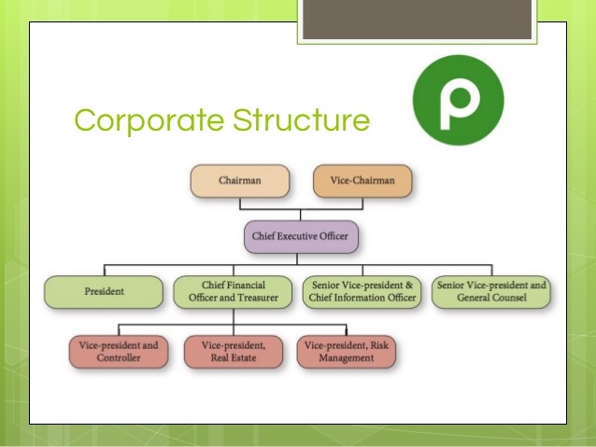
(Publix case 6 PPT, 2016).

  - Appendix 2: SWOT analysis summary
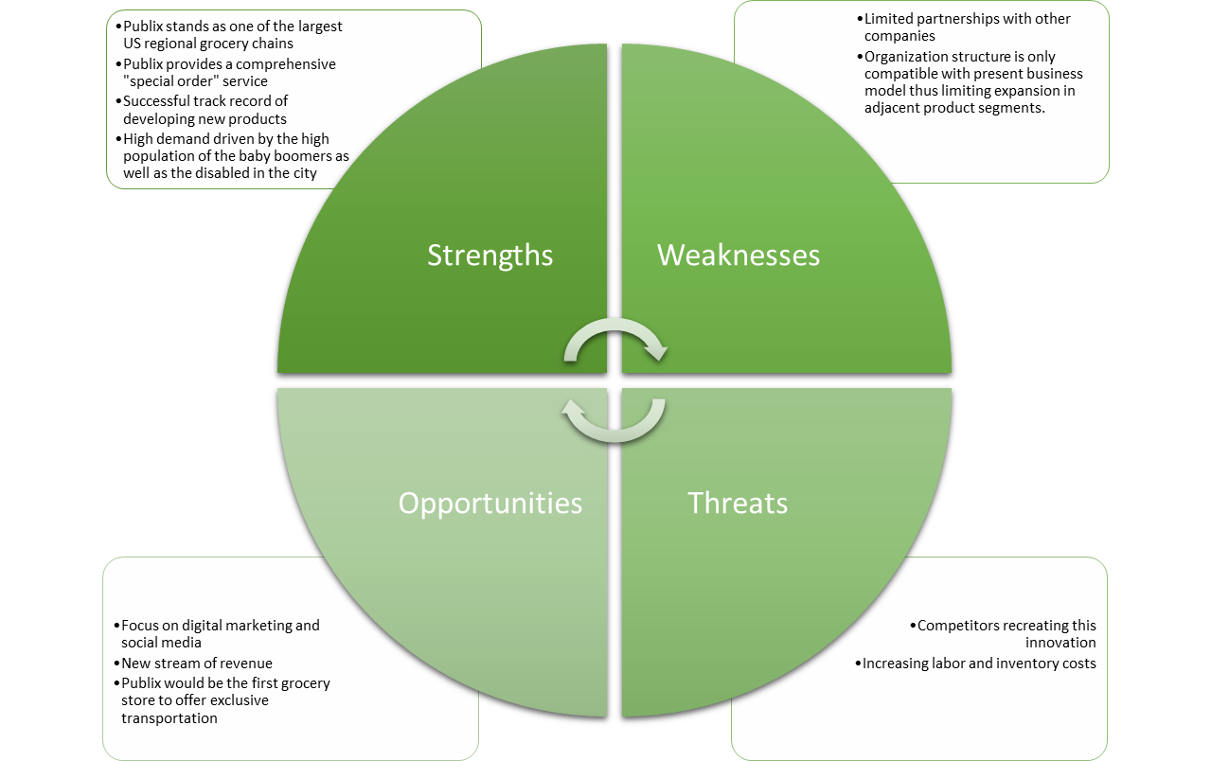

  - Appendix 3: Social Media Competition

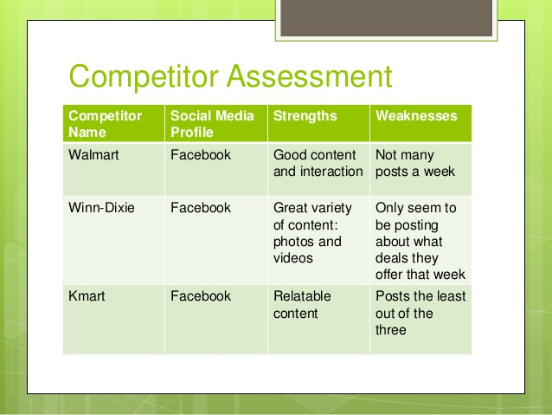

(Publix case 6 PPT, 2016).

  - Appendix 4: The 4 Ps of the Marketing Mix

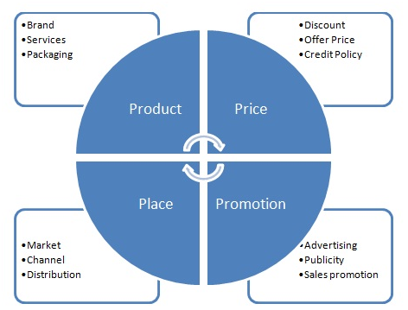
Source: McCarthy (1960).

